**ESNsurvey XVI is out!**

The Erasmus Student Network (ESN) has recently launched the latest edition of the **ESNsurvey**, the largest student-led survey focusing on student exchanges and the internationalisation of higher education from the student perspective.

You can access the survey here: <https://esnsurvey.org/>

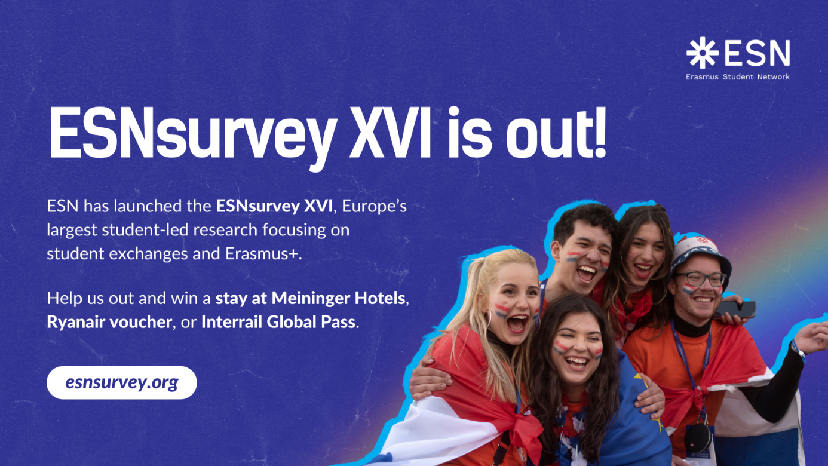

The survey is open to:

* students who have taken part in an exchange during the last two years (or even before 2023),
* all international students pursuing their degrees abroad (including at our University),
* and students who **have not participated** in any exchange experience.

By completing the survey, you’ll have the chance to win a **stay at Meininger Hotels**, a **Ryanair voucher**, or an **Interrail Global Pass**!

Through this initiative, ESN is gathering insights on how to improve the **Erasmus+** programme and other mobility opportunities — and your input is essential. The survey takes approximately **20 minutes**, and all responses are **completely anonymous**.

If you have any questions, feel free to contact the ESN Survey Team at [surveyteam@esn.org](mailto:surveyteam@esn.org).

___________________________________